A000-Asia-China-Jiangsu Province-Cong-Triangular-Jade-Liangzhu culture-2500 BCE

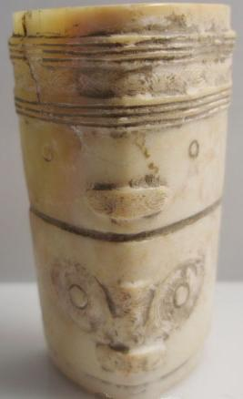 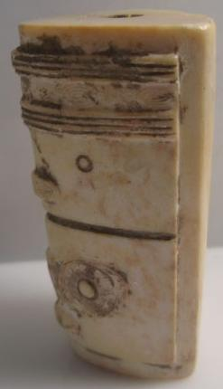 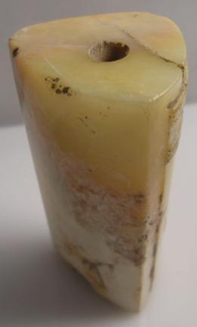 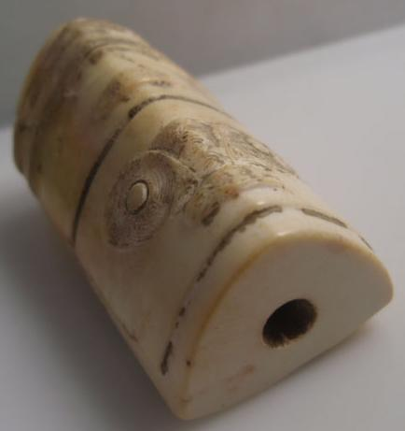

Figs. 1-3. China-Jiangsu Province-Cong-Triangular-Jade-Liangzhu culture-2500 BCE

Case no.: 5

Accession Number:

Formal Label: China-Jiangsu Province-Cong-Triangular-Jade-Liangzhu culture-2500 BCE

**Display Description:**

The Neolithic Liangzhu culture was centered in the Jiangsu Province of China during the third millennium BCE. The Liangzhu jades were highly sophisticated. For instance, this jade cong has two different masks depicting perhaps a deceased ancestor above and his/her animal guardian or spirit below. While it is diminutive in size these features together with its triangular shape distinguishes it as being unusual for it offers a cong devoted to one personage.

**LC Classification:** NK5750.2.A1

Date or Time Horizon: 2500 BCE

Geographical Area: Jiangsu Province

**Map:**

**GPS coordinates:**

Cultural Affiliation:

Medium: jade

Dimensions: H: 5.8 cm. x W: 3.4 cm.

Weight:

Condition: original

Provenance:

**Discussion:**

**References:**

.